**LAB 08 – Advanced Programming**

**Name:** Muhammad Ali Sadiq

**CMS ID:** 210389

**Section:** BSCS-7A

**Task 1 – (i)**

**App.js**

import React, { Component } from 'react';

class App extends Component {

render() {

return (

<div className="App">

<h1>Hello World!</h1>

</div>

);

}

}

export default App;

**index.js**

import React,{Component} from 'react';

import ReactDOM from 'react-dom';

class Welcome extends Component {

constructor(){

super()

this.state={message:'welcome visitor'}

}

changeMessage(){

this.setState({

message: 'Thank you for subscribing'

})

}

render(){

return (

<div>

<h1>{this.state.message}</h1>

<button onClick={()=>this.changeMessage()}>Subscribe</button>

</div>

)}

}

ReactDOM.render(<Welcome />, document.getElementById('root'));

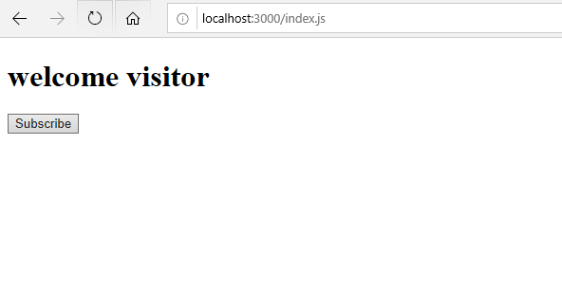

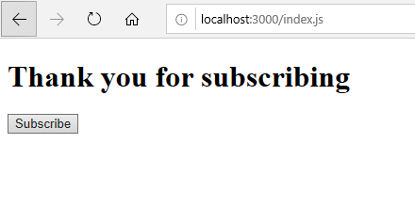

**Task 1 – (ii)**

**App.js**

import React, { Component } from 'react';

import Counter from '/Counter';

class App extends Component {

render() {

return (

<div className="App">

<Counter/>

</div>

);

}

}

export default App;

**index.js**

import React,{Component} from 'react';

import ReactDOM from 'react-dom';

class Counter extends Component {

constructor(props){

super(props)

this.state={count: 0 } }

Increment(){

this.setState({

count: this.state.count + 1

}, ()=>{console.log('call back value',this.state.count)})

console.log(this.state.count)

}

render(){

return (

<div>

<h1>counter - {this.state.count}</h1>

<button onClick={()=>this.Increment()}>Increment</button>

</div> )

}

}

ReactDOM.render(<Counter />, document.getElementById('root'));

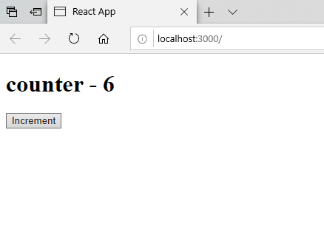

**Task 1 – (iii)**

**index.js**

import React,{Component} from 'react';

import ReactDOM from 'react-dom';

class Counter extends Component {

constructor(props){

super(props)

this.state={count: 0 } }

Increment(){

**this.setState( (prevState)=>({**

**count:prevState.count+1**

**}))**

console.log(this.state.count)

}

render(){

return (

<div>

<h1>counter - {this.state.count}</h1>

<button onClick={()=>this.Increment()}>Increment</button>

</div> )

}

}

ReactDOM.render(<Counter />, document.getElementById('root'));

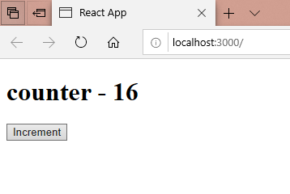

**Task 2**

**index.js**

import React from "react";

import ReactDOM from "react-dom";

class TimerInput extends React.Component {

render() {

return (

<div style={{marginLeft:100}}>

<h3>Input your desired time</h3>

<input type="number" value={this.props.value} onChange={this.props.handleChange} required />

</div>

);

}

}

class Timer extends React.Component {

render() {

return (

<div>

<h1 style={{ fontSize: 100, marginLeft:100 }}>{this.props.value}:{this.props.seconds}</h1>

</div>

);

}

}

class StartButton extends React.Component {

render() {

return (

<div style={{ marginLeft: 130 }}>

<button className="btn btn-lg btn-success" disabled={!this.props.value} onClick={this.props.startCountDown}>Start</button>

</div>

);

}

}

class App extends React.Component {

constructor(props) {

super(props);

this.state = {

seconds: '00',

value: '',

isClicked : false

}

this.secondsRemaining = 0;

this.intervalHandle = 0;

this.handleChange = this.handleChange.bind(this);

this.startCountDown = this.startCountDown.bind(this);

this.tick = this.tick.bind(this);

}

handleChange(event) {

this.setState({

value: event.target.value

})

}

tick() {

var min = Math.floor(this.secondsRemaining / 60);

var sec = this.secondsRemaining - (min * 60);

this.setState({

value: min,

seconds: sec,

})

if (sec < 10) {

this.setState({

seconds: "0" + this.state.seconds,

})

}

if (min < 10) {

this.setState({

value: "0" + min,

})

}

if (min === 0 & sec === 0) {

clearInterval(this.intervalHandle);

}

this.secondsRemaining--

}

startCountDown() {

this.intervalHandle = setInterval(this.tick, 1000);

let time = this.state.value;

this.secondsRemaining = time * 60;

this.setState({

isClicked : true

})

}

render() {

const clicked = this.state.isClicked;

if(clicked){

return (

<div>

<div className="row">

<div className="col-md-4"></div>

<div className="col-md-4">

<Timer value={this.state.value} seconds={this.state.seconds} />

</div>

</div>

</div>

);

}

else{

return (

<div>

<div className="row">

<div className="col-md-4"></div>

<div className="col-md-4">

<TimerInput value={this.state.value} handleChange={this.handleChange} />

<Timer value={this.state.value} seconds={this.state.seconds} />

<StartButton startCountDown={this.startCountDown} value={this.state.value} />

</div>

</div>

</div>

);

}

}

}

ReactDOM.render(<App />, document.getElementById("root"));

